CSF Kappa Index – Paired CSF and Serum sent to ALF
New order available in EPIC from 25/2/26. CSF and Serum should be collected and received together.
AUSLAB Codes: CSFKAP (CSF) and SPKAP (serum)
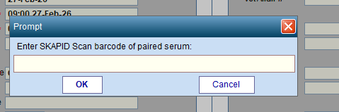
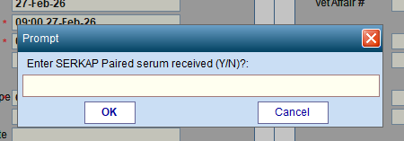
There are two registration prompts on the CSF episode, please complete if serum has been received:
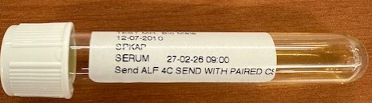
Samples will insert onto a new ALF packing list for paired CSF/Serum. This is a reminder that the serum and CSF need to go together. Serum aliquots made by the track will be labelled as a paired sample:

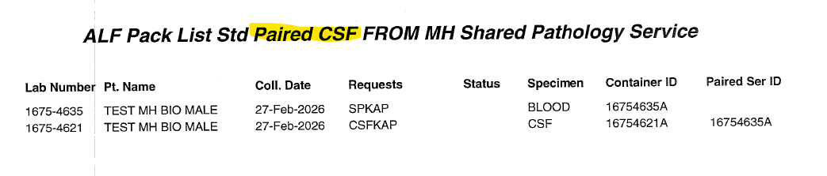
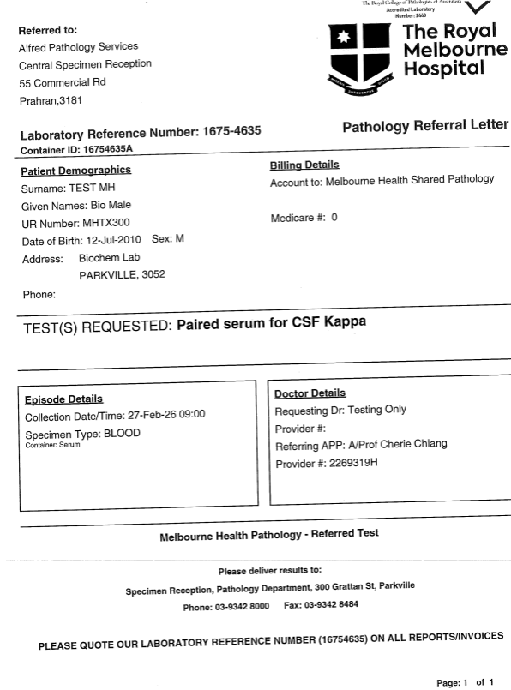
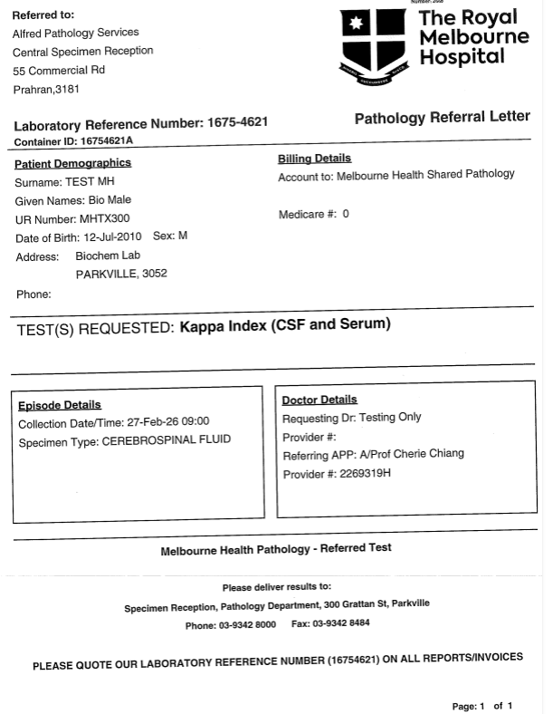
Please pack the serum and CSF aliquots and both cover sheets together in one bag for dispatch to Alfred. Is a serum has not been received, SPKAP can be added to any serum collected +/- 24h of the CSF collection.

